Weekly Status Report to O2O Technologies – Mobile Web UI Development

Duration | 24-Dec-2018 to 28-Dec-2018

Document Summary
Author: Amit Balpathak
Revision Date: December 28, 2018
Customer Reference:
Distribution: Vineeth Narasimhan & SpringCT

Document Created By:

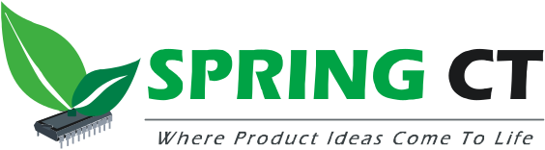

Spring Computing Technologies Pvt. Ltd.

Vijay Commercial Complex, 3rd Floor
Near Guruganesh Nagar, D P Road,
Kothrud, Pune 411 038, India

Phone: +91 20 25391316/19
Fax: +91 20 25391335

http://www.springct.com/

Week 02

Tasks completed this week
Task completed | Remarks
First version of wireframes for India, Singapore and Hong Kong | Done
Study top 5 competitor’s app and come up with positives and negatives. Compare the Kristal apps | Done
UI code walkthrough by Kristal team | Done
POC 1 - Capturing video through browser | Done

Tasks planned but not completed this week
Task not completed | Reasons / Comments
Wireframes concept for Singapore | Working on capturing information for Singapore customers about KYC/Singpass

Plan for the next week
Tasks | Remarks / dependencies
Project setup
MyInfo/Docusign POC
API understanding
Visual designs for Singapore

Schedule slips and recovery actions

– None

Key milestones for the project
No | Milestone | Planned Date | Actual Date | Remarks
 | Milestone #1 –  SpringCT will complete requirement understanding and prepare UX Design (wireframes and visual designs). | 4-Jan-2018

